Understanding the Studio Camera

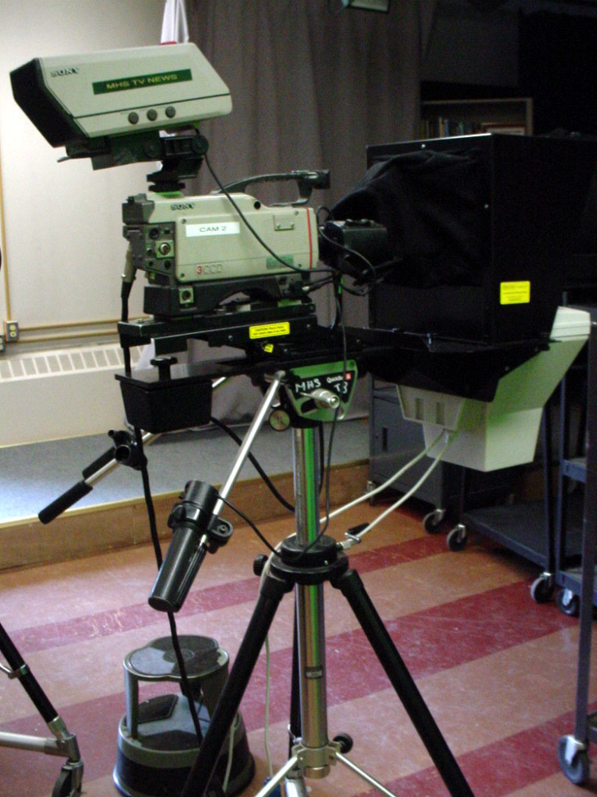
Viewfinder

Lens

Camera Body

Camera Control Unit Cable

Teleprompter Monitor

Focus Control

Zoom Control

Tripod

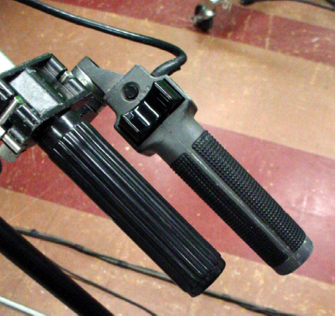

Zoom- By using the button on the grip far to the right you can Zoom T or W.
To the Right is W or Wide angle.
To the Left is T or Telephoto.

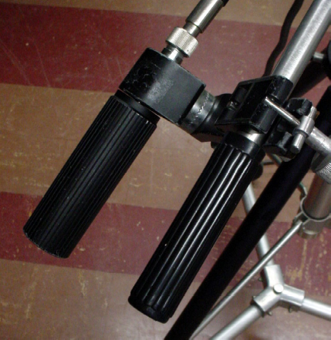

Focus- Turning the far left knob racks the camera’s focus. In order to ensure that your object/ on- camera talent is in focus, zoom in all the way on the object ( if a person, zoom in on eyes) and adjust twist the knob until the object is sharp and in focus.

