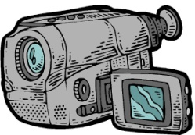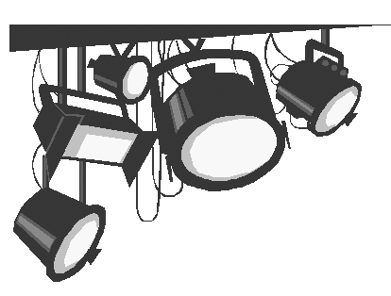

**Video Production II**

**Studio Camera Set-up**

**It is essential to remember these six tasks each time you begin to set-up a camera for a studio shoot.**

1**Communication** - Turn on and ensure that the intercom is working so there

is a clear communication path between you and the director.

2. **Position**- Move the camera into the director’s desired location for the

camera.

3. **Iris** - Work with the director to ensure that an appropriate

amount of light is moving through the camera’s iris.

4. **White Balance**- Have the subject hold up a white piece of paper. Zoom all

the way in on it and manually white balance the camera.

5. **Focus -**  Zoom in on the subject’s eyes and rack the focus until the

picture is clear and sharp.

6. **Compose** - Ask the director for a Camera Shot Sheet. Find your first

camera shot and compose it.